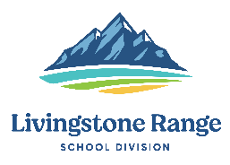
Livingstone Range School Division
Superintendent Report
2021-2022 School Year

Name, Position: Darryl Seguin, Superintendent
Board Meeting Date: February 14, 2022

Highlights

Functions & Meetings

- 2 Board Committee of the Whole Meetings
- Board Professional Development Meeting
- Board Regular Meeting
- Board/ATA Liaison Meeting
- CASSIX Winter Meetings
- Admin Council meeting
- ABD Staff Meeting
- ISS CRM Grade Level Meetings
- 1 on 1’s with school principals
- Monthly Team Collaboration Meeting (Division office staff meeting)
- AERR meeting with Alberta Education
- Meeting with Elders

Key Areas for Next Month

- Board Committee of the Whole meeting
- Admin. Council Meeting
- Regular Board Meeting
- 1 on 1’s with school principals
- Team Collaboration meeting
- FranklinCovey District Educator Advisory Board Meeting
- Alberta Rural Education Symposium
- Inspiring Leadership Parts 1 & 2
- First Nations, Metis & Inuit Education Gathering
- CASS Annual Learning Conference

